EXP 11 - Intermediate code generation – Quadruple, Triple, Indirect triple

AIM :

* To implement the intermediate code generation-quadruple,triple and indirect triple using python program.

ALGORITHM:

There are 3 representations of three address code namely :

1. Quadruple

2. Triples

3. Indirect Triples

1. Quadruple – It is structure with consist of 4 fields namely op, arg1, arg2 and result. op denotes the operator and arg1 and arg2 denotes the two operands and result is used to store the result of the expression.

Advantage

• Easy to rearrange code for global optimization.

• One can quickly access value of temporary variables using symbol table.

Disadvantage

• Contain lot of temporaries.

• Temporary variable creation increases time and space complexity.

2. Triples – This representation doesn’t make use of extra temporary variable to represent a single operation instead when a reference to another triple’s value is needed, a pointer to that triple is used. So, it consists of only three fields namely op, arg1 and arg2.

Disadvantage

• Temporaries are implicit and difficult to rearrange code.

• It is difficult to optimize because optimization involves moving intermediate code. When a triple is moved, any other triple referring to it must be updated also. With help of pointer one can directly access symbol table entry.

3. Indirect Triples – This representation makes use of pointer to the listing of all references to computations which is made separately and stored. Its similar in utility as compared to quadruple representation but requires less space than it. Temporaries are implicit and easier to rearrange code.

CODE:

OPERATORS = set(['+', '-', '*', '/', '(', ')'])

PRI = {'+': 1, '-': 1, '*': 2, '/': 2}

### INFIX ===> POSTFIX ###

def infix_to_postfix(formula):

stack = [] # only pop when the coming op has priority

output = ''

for ch in formula:

if ch not in OPERATORS:

output += ch

elif ch == '(':

stack.append('(')

elif ch == ')':

while stack and stack[-1] != '(':

output += stack.pop()

stack.pop() # pop '('

else:

while stack and stack[-1] != '(' and PRI[ch] <= PRI[stack[-1]]:

output += stack.pop()

stack.append(ch)

# leftover

while stack:

output += stack.pop()

print(f'POSTFIX: {output}')

return output

### INFIX ===> PREFIX ###

def infix_to_prefix(formula):

op_stack = []

exp_stack = []

for ch in formula:

if not ch in OPERATORS:

exp_stack.append(ch)

elif ch == '(':

op_stack.append(ch)

elif ch == ')':

while op_stack[-1] != '(':

op = op_stack.pop()

a = exp_stack.pop()

b = exp_stack.pop()

exp_stack.append(op + b + a)

op_stack.pop() # pop '('

else:

while op_stack and op_stack[-1] != '(' and PRI[ch] <= PRI[op_stack[-1]]:

op = op_stack.pop()

a = exp_stack.pop()

b = exp_stack.pop()

exp_stack.append(op + b + a)

op_stack.append(ch)

# leftover

while op_stack:

op = op_stack.pop()

a = exp_stack.pop()

b = exp_stack.pop()

exp_stack.append(op + b + a)

print(f'PREFIX: {exp_stack[-1]}')

return exp_stack[-1]

### THREE ADDRESS CODE GENERATION ###

def generate3AC(pos):

print("### THREE ADDRESS CODE GENERATION ###")

exp_stack = []

t = 1

for i in pos:

if i not in OPERATORS:

exp_stack.append(i)

else:

print(f't{t} := {exp_stack[-2]} {i} {exp_stack[-1]}')

exp_stack = exp_stack[:-2]

exp_stack.append(f't{t}')

t += 1

expres = input("INPUT THE EXPRESSION: ")

pre = infix_to_prefix(expres)

pos = infix_to_postfix(expres)

generate3AC(pos)

def Quadruple(pos):

stack = []

op = []

x = 1

for i in pos:

if i not in OPERATORS:

stack.append(i)

elif i == '-':

op1 = stack.pop()

stack.append("t(%s)" % x)

print("{0:^4s} | {1:^4s} | {2:^4s}|{3:4s}".format(i, op1, "(-)", " t(%s)" % x))

x = x + 1

if stack != []:

op2 = stack.pop()

op1 = stack.pop()

print("{0:^4s} | {1:^4s} | {2:^4s}|{3:4s}".format("+", op1, op2, " t(%s)" % x))

stack.append("t(%s)" % x)

x = x + 1

elif i == '=':

op2 = stack.pop()

op1 = stack.pop()

print("{0:^4s} | {1:^4s} | {2:^4s}|{3:4s}".format(i, op2, "(-)", op1))

else:

op1 = stack.pop()

op2 = stack.pop()

print("{0:^4s} | {1:^4s} | {2:^4s}|{3:4s}".format(i, op2, op1, " t(%s)" % x))

stack.append("t(%s)" % x)

x = x + 1

print("The quadruple for the expression ")

print(" OP | ARG 1 |ARG 2 |RESULT ")

Quadruple(pos)

def Triple(pos):

stack = []

op = []

x = 0

for i in pos:

if i not in OPERATORS:

stack.append(i)

elif i == '-':

op1 = stack.pop()

stack.append("(%s)" % x)

print("{0:^4s} | {1:^4s} | {2:^4s}".format(i, op1, "(-)"))

x = x + 1

if stack != []:

op2 = stack.pop()

op1 = stack.pop()

print("{0:^4s} | {1:^4s} | {2:^4s}".format("+", op1, op2))

stack.append("(%s)" % x)

x = x + 1

elif i == '=':

op2 = stack.pop()

op1 = stack.pop()

print("{0:^4s} | {1:^4s} | {2:^4s}".format(i, op1, op2))

else:

op1 = stack.pop()

if stack != []:

op2 = stack.pop()

print("{0:^4s} | {1:^4s} | {2:^4s}".format(i, op2, op1))

stack.append("(%s)" % x)

x = x + 1

print("The triple for given expression")

print(" OP | ARG 1 |ARG 2 ")

Triple(pos)

OUTPUT:

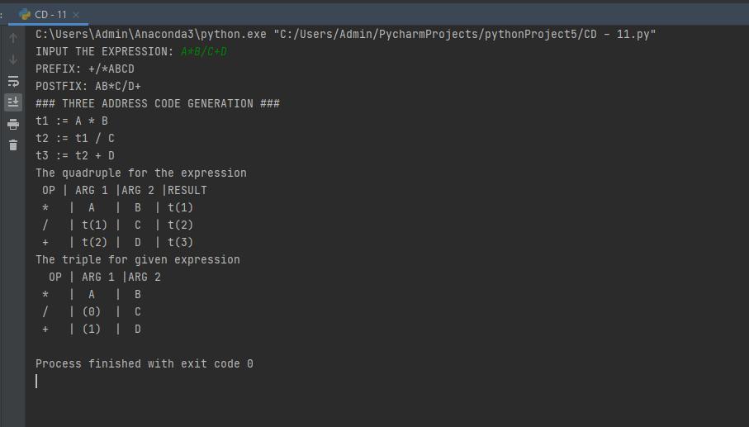

RESULT:

* Hence the the intermediate code generation-quadruple,triple and indirect triple is implemented using python program.